Name:…………………………………………………………………………………………

Date:………………………………Place………………………………………

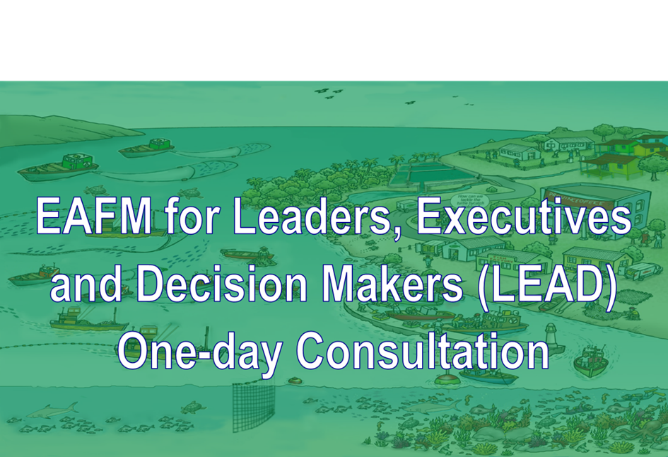

Version 1
Version 1

How to use this booklet

You will work in groups for much of this course, and you will mostly be using cards, pens and paper for group work. It is USEFUL to you record the outputs from your group work for later reference. Use the relevant sections of this booklet to write your notes.

Module  number | Activity/group work | Booklet  page number
II | Threats, issues and vision for the future | 3
III | Moving towards EAFM continuum | 4
IV | Global/regional conventions, instruments and arrangements | 5
IV | National laws/policies | 6
V | Linkage between policies and plans | 7
VI | EAFM planning process | 8
VII | Policy trade-offs | 9
VIII | Existing vs ideal governance structure | 10
IXa | What you can do to promote EAFM | 11
IXb | What you agency can do to promote EAFM | 12
IXc | What your country can do to promote EAFM | 13
X | Next steps (What/How/When/Who) | 14

II. List the threats and issues for your fisheries and add key words of the vision for the future.
Threats and issues

Agreed vision key words

III. Moving towards EAFM continuum: complete this table for your national fisheries

To what extent are EAFM principles being applied in your fishery? Plot your fishery on a scale of 0-5 (where 0 = none; and 5 = excellent)

EAFM principles | 0 ………………………………………………………………………………..………………...…5
- Good governance | …………………………………………………………………………………………..>
- Appropriate scale | ………………….……………………………………………………………………….>
- Increased participation | ……………………………………………………………………………………………>
- Multiple objectives | ……………………..…………………………………………………………………….>
- Cooperation and coordination | ……………………………………………………………………………………………>
- Adaptive management | ……………………………………………………………………………………………>
- Precautionary approach | ……………………………………………………………………………………………>

IV. List examples of global/regional conventions, instruments and arrangements that relate to fisheries, the environment and human well-being (e.g. poverty alleviation).

Global/regional conventions, instruments and arrangements

IV. List national legislations/policies that relate to fisheries, the environment and human well-being (e.g. poverty alleviation).

National legislation/policies
V. Fill in examples of the link between policy and management actions.
Plans - Linking policy to management actions

VI. EAFM Planning process

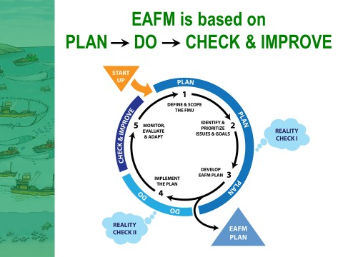

What is your role in the planning process?

VII. Policy trade-offs
Examples of policy trade-offs and mismatches among policies

VIII. Diagrams of existing and ideal governance structures
Existing governance structure

Ideal governance structure

IXa. Fill in what you, as a LEADer, can do to promote EAFM
What you can do to promote EAFM

IXb. Fill in what your agency can do.

What your agency can do to promote EAFM

IXc. Fill in what your country can do to promote EAFM

What your country can do to promote EAFM

X. Fill in the next steps of actions to promote EAFM

Next steps
What | How | When | Who

